Roundabout Design Aid

Prepared by the
Geometric Design Unit
September 2025

Engineering Manual Preamble
This manual provides guidance to administrative, engineering, and technical staff. Engineering practice requires that professionals use a combination of technical skills and judgment in decision making. Engineering judgment is necessary to allow decisions to account for unique site-specific conditions and considerations to provide high quality products, within budget, and to protect the public health, safety, and welfare. This manual provides the general operational guidelines; however, it is understood that adaptation, adjustments, and deviations are sometimes necessary. Innovation is a key foundational element to advance the state of engineering practice and develop more effective and efficient engineering solutions and materials. As such, it is essential that our engineering manuals provide a vehicle to promote, pilot, or implement technologies or practices that provide efficiencies and quality products, while maintaining the safety, health, and welfare of the public. It is expected when making significant or impactful deviations from the technical information from these guidance materials, that reasonable consultations with experts, technical committees, and/or policy setting bodies occur prior to actions within the timeframes allowed. It is also expected that these consultations will eliminate any potential conflicts of interest, perceived or otherwise. MDOT Leadership is committed to a culture of innovation to optimize engineering solutions.
The National Society of Professional Engineers Code of Ethics for Engineering is founded on six fundamental canons. Those canons are provided below.
- Engineers, in the fulfillment of their professional duties, shall:
- Hold paramount the safety, health, and welfare of the public.
- Perform Services only in areas of their competence.
- Issue public statement only in an objective and truthful manner.
- Act for each employer or client as faithful agents or trustees.
- Avoid deceptive acts.
- Conduct themselves honorably, reasonably, ethically and lawfully so as to enhance the honor, reputation, and usefulness of the profession.
If you require assistance accessing this information or require it in an alternative format, contact the Michigan Department of Transportation’s (MDOT) Americans with Disabilities Act (ADA) coordinator at Michigan.gov/MDOT-ADA.
This document will assist the designer in the design of roundabouts by providing clarification and preferences used by MDOT. Further information and detail may be found in NCHRP Report 1043.

Design Parameters
This table and bullet points are to be completed by the designer and submitted to the MDOT Geometric Design Unit for review:
Intersection | Leg 1 | Leg 2 | Leg 3 | Leg 4 | Leg 5 | Leg 6
Half width, ft, (V=)
Entry width, ft, (E=)
Effective Flare, ft, (L’=)
Entry Radius, ft, (R=)
Entry Angle (Ø=)
R1 Radius (ft) / V1 Speed (mph) *
R2 Radius (ft) / V2 Speed (mph) *
R3 Radius (ft) / V3 Speed (mph) *
R4 Radius (ft) / V4 Speed (mph) *
R5 Radius (ft) / V5 Speed (mph) *
Inscribed Circle Diameter, ft, =
* These Rx and Vx variables are further defined and explained in the “Speed Management” section of this Design Aid.
- Design Vehicle:
- Circulating Roadway Width:
- Truck Apron Width, if present:
- Stopping Sight Distance:
- Intersection Sight Distance:
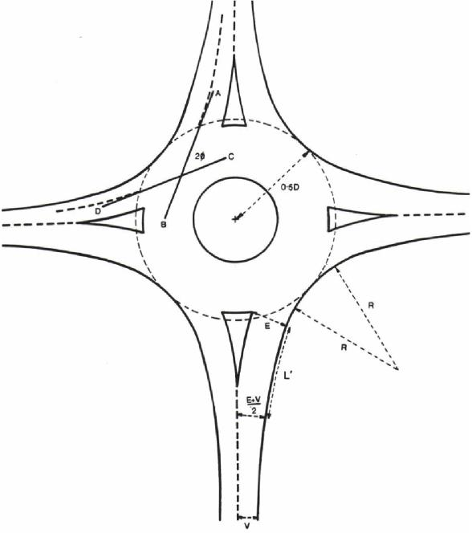

General Notes
The following design ranges are presented with a recommended minimum and maximum. The recommended standard/starting value for a roundabout is the minimum value presented in these ranges. Roundabout safety is improved by lowering speeds and reducing the speed of the fastest path. One of the most effective ways of doing this is narrower widths. The smallest value that serves the design vehicle is recommended for use.

Single Lane Roundabout
Entry width 14 - 18 ft
Circulatory width 16 - 20 ft
Entry radius 50 ft minimum
Exit radius 100 ft minimum, generally 200’ - 400’
Exit width 18 – 20 ft

Multilane Roundabout
Entry width 24 - 30 ft
Circulatory width 28 - 32 ft
Entry radius > 65 ft minimum

Inscribed Circle Diameter
The following ranges are typical of roundabout diameters, assuming the Department practice of an AASHTO WB-67 being used as the design vehicle. Other values may be appropriate given different design vehicle assumptions.
Single Lane 120-180 ft
Double Lane 140-180 ft
Triple Lane* 190-200 ft

Splitter Islands
Splitter islands should generally be 50 ft to 100 ft in length
On high-speed approaches (>45 mph), splitter islands should desirably be a minimum of 150 ft in length
The splitter island should be extended beyond the end of the exit curve

Circulatory Width
Circulatory widths should be at least as wide as the maximum entry width - and may be up to 120 percent of the maximum entry width.

Entry Angle
Entry angles should be between 20 and 40 degrees. 30 degrees is considered optimal.

Cross-Slope
Cross-slopes should be 1.5% or 2.0% towards the outside of the roundabout (i.e. sloped away from the central island). A 1.5% cross-slope is preferable to a 2.0% cross-slope.

Truck Apron
Truck aprons should generally be 10 ft to 15 ft in width and should be constructed in the same plane (have the same 1.5% or 2.0% cross-slope) as the circulatory roadway.

Curb and Gutter
Splitter Islands Detail B or Detail F curb and gutter should be used. (Detail F curb and gutter is preferred where pedestrians are prevalent).
Entering and Exiting Radii Detail B curb and gutter should be used.
Truck Apron Detail D curb and gutter should be used.
Central Island Detail E curb should be used.

Sight Distance
See section 9.5 of NCHRP Report 1043. It is important to note that that unlimited sight distance may not be desirable. Evidence suggests providing no more than the minimum sight distance may lead to lower speeds which reduces the risk of high severity crashes. Limiting sight distance by mounding up the central island or obscuring sight distance to an extent on the approaches may lessen the chances of vehicles ‘racing’ to enter before a vehicle on another approach. This may have a beneficial effect on entry speeds and yielding behavior.

Entry Speeds
The recommended maximum theoretical entry design speeds for roundabouts are:
Single-Lane 25 mph
Multi-Lane 30 mph
See NCHRP 1043, Chapter 10, Exhibit 10.109 for speed and radius relationship given a positive or negative 2% superelevation.

Truck Operations
Multi-lane roundabouts are designed to accommodate truck turning movements in one of three ways:
Case 1 Operations – Case 1 roundabouts are designed such that trucks may encroach into adjacent lanes while approaching, entering, circulating, and exiting the roundabout.
Case 2 Operations – Case 2 roundabouts are designed such that trucks are accommodated within their own lane as they approach and enter the roundabout, but may encroach into adjacent lanes while circulating, and exiting the roundabout.
Case 3 Operations – Case 3 roundabouts are designed such that trucks are accommodated within their own lane while approaching, entering, circulating, and exiting the roundabout (i.e. there is no encroachment).
It is typical MDOT practice to design for Case 2 truck operations. However, Case 1 or Case 3 truck operations may be appropriate in some circumstances.

Lighting
Lighting should be provided at all roundabouts, highlighting approach and exit areas, as well as the circulatory roadway.

*Triple Lane Roundabouts
Three-lane roundabouts are not recommended due to concerns with safety and operations. Other alternatives should be considered first if the need for a three-lane roundabout is identified.
Please note that all the ranges are meant to guide the designer in designing the roundabout. Small deviations from these ranges may not affect the performance of the roundabout.

Speed Management

Defining and Measuring Fastest Paths
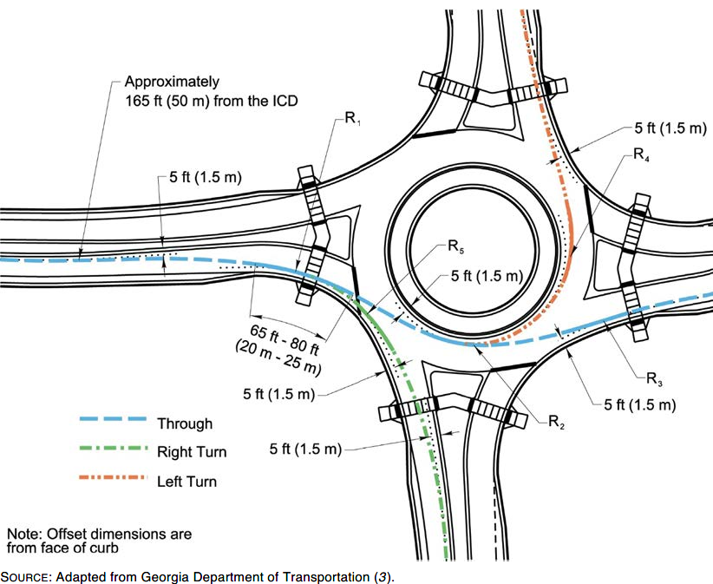
NCHRP 1043, Chapter 9, Exhibit 9.7. Vehicle path radii.
Radius (Rx) | Description | Range of Speeds (Vx)
Entry Path Radius, R1 | The minimum radius on the fastest through path prior to the yield line. This is not the same as Entry Radius. | Single Lane 20 to 25 mph*  Multilane 25 to 30 mph*
Circulating Path Radius, R2 | The minimum radius on the fastest through path around the central island. | 15 to 25 mph
Exit Path Radius, R3 | The minimum radius on the fastest through path to the exit. | V2 + Acceleration over the path to the exit crosswalk*
Left Turn Path Radius, R4 | The minimum radius on the path of the conflicting left-turn movement. | 10 to 20 mph
Right Turn Path Radius, R5 | The minimum radius on the fastest path of a right-turning vehicle. | 15 to 20 mph*
WisDOT, FDM Chapter 11-26, Table 30.2, Modified
* Notes: Under conditions where sufficient numbers of pedestrians are present, desirable values for fastest path speeds should aim for the lower value of the ranges presented.
The V2 variable is further defined and explained in the “Vehicle Speed Estimation” section of this Design Aid.

Speed Consistency
In addition to achieving the appropriate design speed for the fastest path movements, the relative speeds between consecutive geometric elements should be minimized as well as between conflicting traffic streams. Ideally, the relative differences between all speeds within the roundabout will be no more than 10 to 15 mph with 12 mph desirable. Typically, the R2 values are lower than the R1 values. With either single or multilane entries, R2 values should be lower than the R3 values.
The desirable maximum R1 radius is 175 ft for a single lane roundabout and 280 ft for a multilane roundabout. Generally, for urban roundabouts with pedestrian accommodations a lower speed entry is desirable. A typical R1 may range between 150 and 230 feet. Rural roundabouts typically allow slightly higher entry speed than urban roundabouts. The R1 and R2 should be used to control exit speed. Typically, the speed relationships between R1, R2, and R3 as well as between R1 and R4 are of primary interest. Along the through path, the desired relationship is R1>R2<R3, where R1 is also less than R3. Similarly, the relationship along the left-turning path is R1>R4.
For most designs, the R1-R4 relationship will be the most restrictive for speed differential at each entry.

Construction and Measurement of Vehicle Fastest Paths
To determine the speed of a roundabout, the fastest path allowed by the geometry is drawn. This is the smoothest, flattest path possible for a single vehicle, in the absence of other traffic and ignoring all lane markings, traveling through the entry, around the central island, and out the exit. The design speed of the roundabout is determined from the smallest radius along the fastest allowable path. The smallest radius usually occurs on the circulatory roadway as the vehicle curves to the left around the central island. The centerline of the vehicle path is drawn relative to these particular geometric features of the roundabout:
- 5 ft from a curb face
- 5 ft from a roadway centerline
- 3 ft from a painted edge line

Fastest Vehicle Path Through a Roundabout
Figure 9.7 from chapter 9 of NCHRP 1043 illustrates the offsets for calculating the fastest path through a roundabout. The figure can be found in the Defining and Measuring Fastest Paths section of this document.
The entry path radius, R1, is a measure of the deflection imposed on a vehicle prior to entering the roundabout. The ability of the roundabout to control speed at the entry is a proxy for determining the potential safety of the roundabout and whether drivers are likely to yield to circulating traffic. The construction of the fastest path should begin at least 165 ft in advance of the yield line, using the appropriate offsets as identified in the previous discussion. The R1 radius should be measured as the smallest best-fit circular curve over a distance of at least 65 ft to 80 ft, in the vicinity of the yield line. See Figure 9.7 for a visual representation of the fastest paths.

Vehicle Speed Estimation
Roundabouts are typically constructed with a 1.5% or 2.0% cross-slope. Therefore, as vehicles traverse the roundabout, they will experience superelevation rates (e) of +0.015 and -0.015 (for 1.5% cross-slopes) or +0.020 and -0.020 (for 2.0% cross-slopes) as they travel through the various curves along their paths. Based on the AASHTO equations relating design speed to horizontal curve radius, side friction factor, and superelevation rate, the vehicle speeds through the roundabout can be estimated. The following two equations may be used to predict the vehicle speeds:
- V = 3.4415R^{0.3861} (for e = +0.020) NCHRP 1043, Chapter 9, Equation 9.3, Modified
- V = 3.4614R^{0.3673} (for e = -0.020) NCHRP 1043, Chapter 9, Equation 9.4, Modified
Where: V = Predicted speed (mph), R = Radius of curve (ft), e = Superelevation (ft/ft)
Exhibit 10.109 illustrates this speed-radius relationship in a graphical format (and may be used to roughly approximate speeds for a 1.5% cross slope, as well):
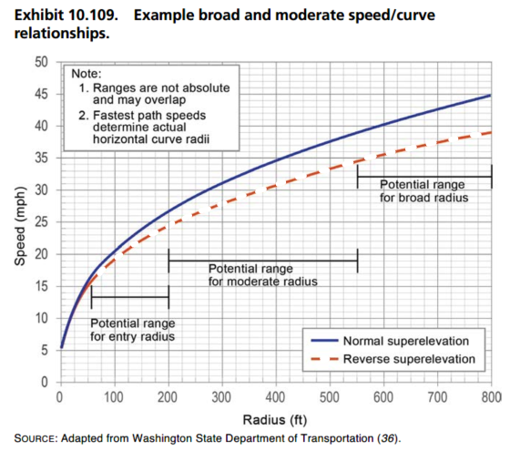
NCHRP 1043, Chapter 10, Exhibit 10.109, Modified
These speed-radius relationship equations and graph generally provide a reasonable prediction for the left-turn and through movement circulating speeds. However, this method of speed determination does not consider the effects of acceleration and, therefore, may under-predict exit speeds in cases where the exit path radius is large. At locations with a large exit radius, the acceleration characteristics of the vehicles will govern the actual speeds that can be achieved. Therefore, it is recommended that NCHRP 1043 Equations 9.3 and 9.4 as well as Exhibit 10.109 be used strictly for estimating the R1, R2, R4, and R5 speeds (correspondingly denoted as V1, V2, V4, and V5). To better predict the actual exit speeds (V3), the following equation should be used to account for acceleration of vehicles from the circulating (V2) speed (as estimated based on the R2 path radius in accordance with the previously described procedures) to a point of interest along the exit leg (typically a crosswalk):
- $V_{3}=min\left\{\begin{matrix}V_{3p} \\ \frac{1}{1.47}\sqrt{{\left(1.47V_{2}\right)}^{2}+13.8d_{23}}\end{matrix}\right\}$ NCHRP 1043, Chapter96, Equation 9.7, Modified
Where: V₃ = Actual exit speed (mph), V₂ = Circulatory speed for through vehicles based on R2 path radius (mph), d₂₃ = Distance along vehicle path between midpoint of R2 path and point of interest on exit path (mph)

Measuring Entry Angle (Phi)
The entry angle is the angle created between entering and circulating traffic paths. Multi-lane entrances or exits are assumed to be measured for the center of the approach or exit, not the center of each lane in particular.

Method 1
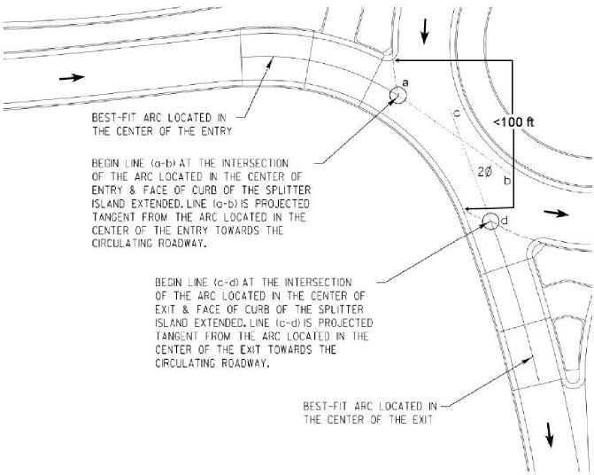
Method 1, WisDOT, FDM Chapter 11-26, Figure 30.21- Modified
Method 1 is used when the distance from the left side of the nearest entry to the beginning of the next exit is less than 100 feet. This yields a measurement of 2Ø as shown above. The 100 feet dimension is taken from the edge of the splitter island to the projection of point d at the curb line.

Method 2
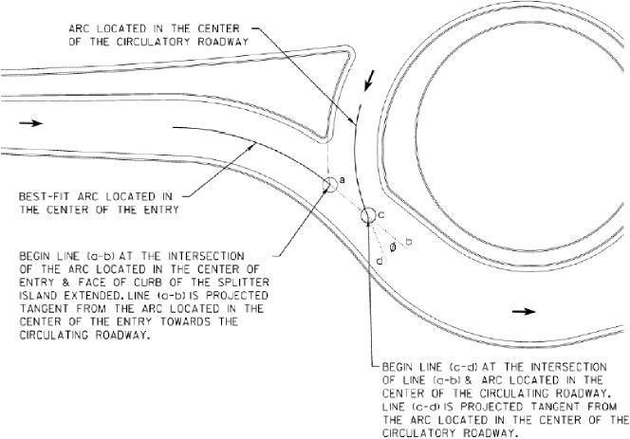
Method 2, WisDOT, FDM Chapter 11-26, Figure 30.22
Method 2 is used when the distance from the left side of the nearest entry to the beginning of the next exit is more than 100 feet (or does not exist, such as at a T intersection). This yields a measurement of Ø as shown in Figure 30.22 from WisDOT FDM, not 2Ø as in Method 1.

Path Overlap Check
Path overlap occurs in multilane roundabouts when that natural path of a vehicle overlaps the path of another vehicle from the adjacent lane. This can be prevented by creating a short tangent distance of 1 to 2 vehicles in length (25 to 50 feet) in the area between the circulatory roadway and the entry or exit curve. This distance is measured from a point at the middle of the approach or exit in question at the yield line to the center of the circulatory roadway.
A simple check to determine the proper alignment of an approach and to generally avoid path overlap is to continue the splitter island curve into the circulatory roadway. This curve should run tangentially to the central island at a minimum. If it crosses into the central island, the approach may not be properly aligned and may need to be realigned. Note that this does not necessarily verify the tangent distance as specified above.
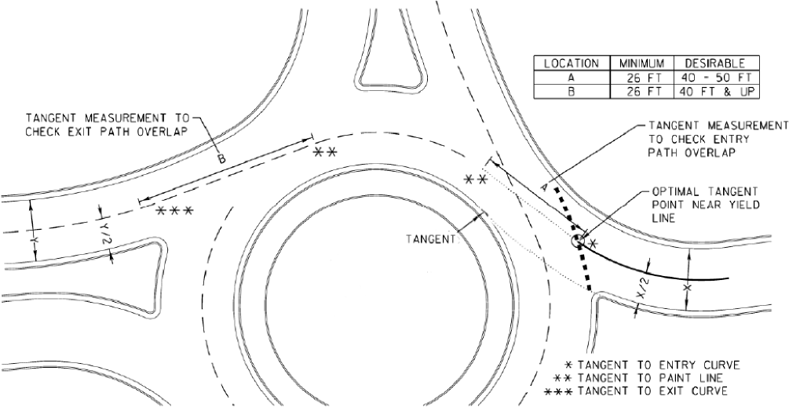
WisDOT, FDM Chapter 11-26, Figure 30.17- Modified

Compact Roundabouts

Application
- Lower speed roads (≤ 35 mph) where other constraints (such as ROW) are present and prevent a traditional design. In special cases, can be used on higher speed (45mph+) roadways. These cases will have increased requirements for tapers, islands, and other features.
- Intersection volumes less than 1500 vph total, with low (<5%) commercial traffic (trucks and busses).
- Junctions of two lane, two way roads without large commercial drives nearby. Compact roundabouts should be limited to single lanes.
- To help promote safe operations, the design of compact roundabouts generally aligns passenger cars on the approach in such a way as to naturally follow the circulatory roadway and minimize running over the central island to the extent possible. Due to the small footprint, large vehicles are typically required to over-run the fully traversable central island.

Design
- Inscribed circle diameter range is usually 50 to 90 feet. When the diameter exceeds 90 feet, a traditional design is preferred.
- Splitter islands should be at least 50 square feet and provide sufficient deflection to align vehicles with the circulatory roadway. A 6 feet island width at the crossing is required if pedestrians are present and a refuge is desired. A smaller width may be used for single stage crossings.
- The following should be examined when determining the splitter island type-
  - Consider a raised island (using type B curb) if:
    - All design vehicles can navigate the roundabout without tracking over the splitter islands
    - Sufficient space is available to provide an island with the minimum area, and/or
    - Pedestrians are present at the intersection with regular frequency.
  - Consider a traversable island (using Type D curb or corrugated concrete) if:
    - Some design vehicles must travel over the splitter islands and truck volumes are minor, and
    - Sufficient space is available to provide an island with the minimum area.
  - Consider a flush (painted) island if:
    - Vehicles are expected to travel over the splitter island area with relative frequency to navigate the intersection,
    - An island with a minimum area of 50 square feet cannot be achieved, and
    - Intersection has slow vehicle speeds (25 mph or less)
    - Flush splitter islands are generally discouraged.
  - Central islands are meant to be fully traversable. The first option is that the central island will use slightly raised curb (type D) and have a flush island (2% or less) with contrasting pavement. Another option is to use a mounded island, with height that should be limited to less than 5 inches and have slopes of 5 to 6%. Central island diameters are typically 16 to 45 feet depending on the design vehicle.
  - Approach widths are typically 12-14 feet, with circulatory widths of 14-16 feet. These narrow lane widths help to ensure a reduction in vehicle speed.
  - The circulatory roadway should be sloped outward at 1.5-2.0%.
  - Paved aprons on the outside of approaches or circulating roadway may be needed for larger design vehicles to prevent rutting behind the curb.
  - Deflecting the through path of a vehicle and slowing vehicle entry speeds are critical. Avoid flat or tangential designs that are not deflected by the splitter islands and central island.
  - Capacity analysis is still typically needed for compact designs, but certain measures, such as entry angle and fastest path may not be as critical to the design due to the very slow operating speeds present.
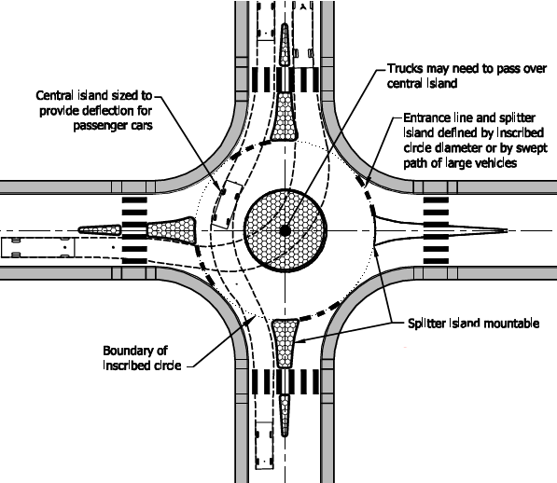
Exhibit 6-38 from NCHRP 672
If you require assistance accessing this information or require it in an alternative format, contact the Michigan Department of Transportation’s (MDOT) Americans with Disabilities Act (ADA) coordinator at Michigan.gov/MDOT-ADA.

