MICHIGAN

DEPARTMENT OF TRANSPORTATION

SPECIAL PROVISION

FOR

**GEOTEXTILE RETAINING WALL**

BRG:TNB 1 of 3 APPR:DMG:RWS:03-03-21

**a. Description.** This work consists of constructing a temporary geotextile reinforced retaining wall for the staged construction and subsequent removal, if necessary. Complete this work in accordance with the plans, standard specifications, and this special provision. This special provision is for use in constructing temporary retaining walls up to 8 feet high, with no sloping backfill.

**b. Materials.** Use structure backfill meeting the requirements for granular material Class IIIA in accordance with Table 902-3 of the Standard Specifications for Construction.

Furnish woven polyester or polypropylene geotextile reinforcement with a minimum 950 pounds (lbs)/foot (ft) Allowable Tensile Strength (*ASTM D4595*) at 5 percent or less strain. Fabric must also have a minimum Ultimate Tensile Strength (*ASTM D4595*) of 4,800 lbs/ft in the machine direction, and permittivity not less than 0.1 sec-1 (*ASTM D4491/D4491M*). Provide Test Data Certification prior to starting the work, documenting the specified properties as Minimum Average Roll Values.

**c. Construction.** Construct the retaining wall in wrapped layers not exceeding 12 inches; with individual compacted lift thickness not exceeding 6 inches (see Figure 1 herein). The first lift in each layer (placed directly on the geotextile) must be at least 4 inches thick to minimize damage to the geotextile. Repair or replace damaged geotextile as directed by the Engineer at no additional cost to the contract.

Do not exceed 8 feet maximum wall height. Do not have a slope at either the top or bottom of the wall greater than 1V:10H. If the bottom of the wall is bearing on soil, embed the wall at least 6 inches.

Place the first layer of geotextile reinforcement on the prepared grade so the strength specified previously acts perpendicular to the wall and as shown on the plans. Space geotextile reinforcement equally (vertically), as shown on the plans. Completely install each layer of geotextile reinforcement and backfill before beginning installation of the succeeding layer of reinforcement. Ensure the elevation of each geotextile layer is within ±1.25 inches of the elevation shown on the plans.

Place each geotextile layer as shown on the plans, without wrinkles. No seams or overlaps are permitted parallel to the wall face; 24-inch minimum overlaps are allowed perpendicular to the wall face. Place seams, where permitted, facing upward for inspection purposes.

Place backfill in accordance with the construction sequence, to prevent wrinkles and folds from developing in the geotextile. Do not end-dump backfill directly on the geotextile. Compact each backfill layer to at least 95 percent of the maximum unit weight. Do not use vibratory rollers, sheepsfoot or other rollers with protrusions.

Use a temporary form (or other suitable means) to maintain a uniform vertical wall face. Use pins, pegs or the geotextile manufacturer’s recommended method in addition to the temporary form as needed to anchor the geotextile until the specified cover material is in place.

For the top layer of geotextile reinforcement, maintain a minimum of 3 inches of structure backfill over the geotextile reinforcement. Do not pave directly on or allow loose hot mix asphalt to contact the geotextile reinforcement.

**d. Measurement and Payment.** The completed work, as described, will be measured and paid for at the contract unit price using the following pay item:

**Pay Item Pay Unit**

Geotextile Retaining Wall Square Yard

**Geotextile Retaining Wall** will be measured in place. The length and vertical height will be measured and the projected area of wall face in square yards will be calculated. No allowance will be made for batter or undulation of wall surface or for allowable overlap. Payment includes furnishing, placing and compacting retaining wall backfill; furnishing and placing geotextile and temporary forms; any work necessary to establish grades; repair or replacement of damaged geotextile, and complete or partial removal and disposal, as necessary.

**Figure 1: Construction Sequence for Geotextile Wall(s)**

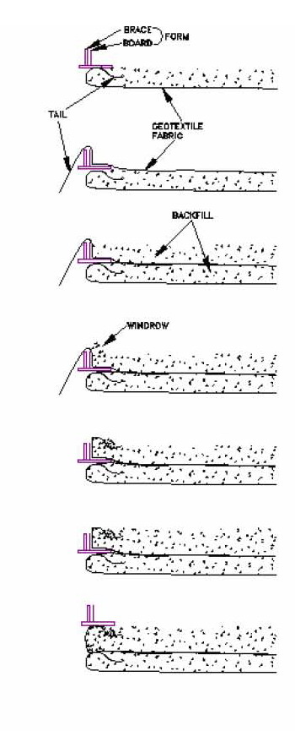

1. A form typically consisting of a continuous wooden board with a series of metal “L” brackets, of height slightly greater than the layer height (1 ft) is placed on the previously completed layer (or the prepared surface for the first layer).
2. The geotextile is unrolled and positioned so that 3.5’ ± extends over the top of the form and hangs loose. The geotextile may be unrolled parallel to the wall if sufficiently wide.
3. The first lift of backfill is placed on the geotextile and compacted to one half the total layer thickness (6” maximum) with conventional light compaction equipment.
4. A windrow shall be placed along the form to the full layer height using a blade or by hand. Care must be taken to protect the geotextile in place.
5. The loose end of the geotextile (i.e. the “tail”) is then folded back onto the windrow and anchored in place with backfill material.
6. The remaining lift of backfill (6”) shall be placed and compacted to the plan layer thickness (1ft maximum).
7. The form is then carefully removed from the face of the wall and reset upon the completed layer in preparation for the subsequent layer.