Watershed delineation with Google Earth

- Go to https://ngmdb.usgs.gov/topoview/viewer/#12/42.2595/-85.2542
- Navigate on the map to the appropriate location. Select 24K for the appropriate topo map. Click on the rectangle(s) for the appropriate topo map(s).
- Select the topo map from the most recent year in the lower right of the screen (beware that EGLE may be using topo maps from different years. If the drainage area is close to 2 sq. miles, send request to verify). Select “Download KMZ.”

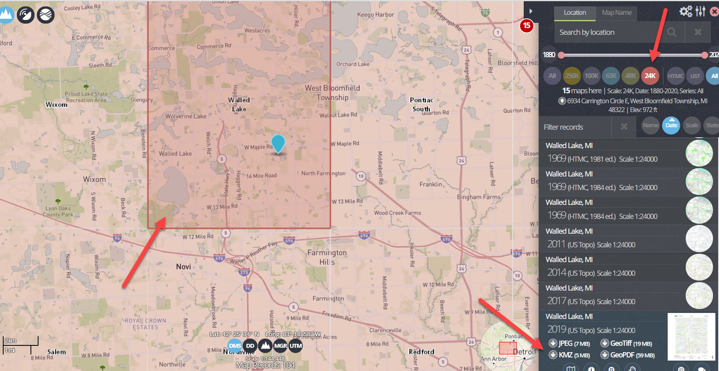

- Extract zip files before opening appropriate KMZ topo map (double clicking file will automatically open in Google Earth).
- Create a folder under “My Places” in Google Earth. Right click and “Add- Folder.”

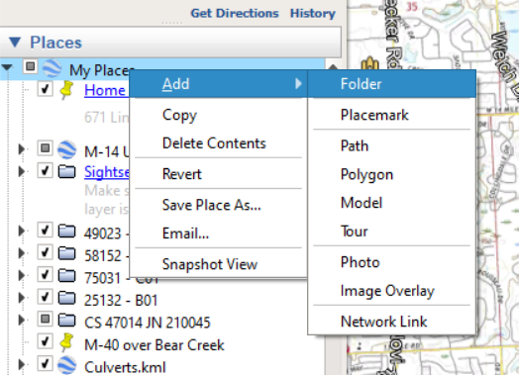

- Drag and drop the topo maps from the Temporary folder into the folder created above.
- Delineate watershed by right clicking on the folder and selecting “Add – Polygon.”

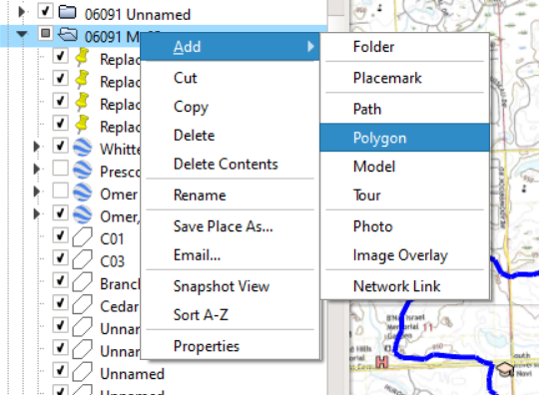

- Select the “Style, Color” tab in the new polygon dialog box. Select a color other than white for the outline, adjust the width to 4.0, and change the type to “outlined.”

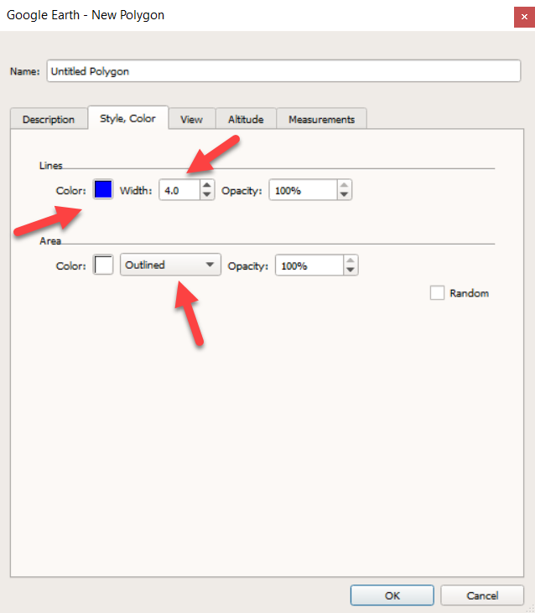

- Select the “Measurements” tab. Change the area units to square miles.

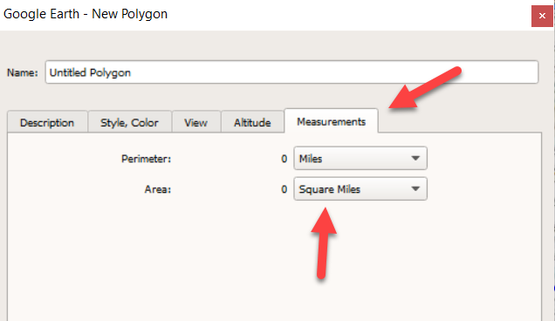

- Begin delineating your watershed. Once completed, click “OK” in the new polygon dialog box to save.
- The watershed polygon can be edited by right clicking the polygon your created folder within “My Places” and selecting “Properties.”

Flowpath delineation:

- Right click on the folder created above and select “Add – Path.”

- Select the “Style, Color” tab in the new path dialog box. Select orange for sheet flow, green for waterway, and blue for small trib. Change width to 4.0.

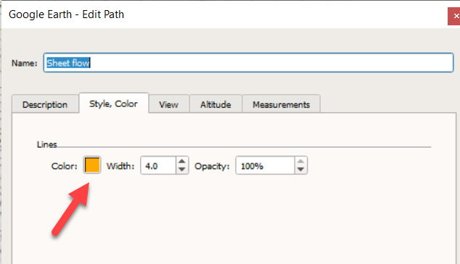

- Select the “Measurements” tab and verify the units are in feet.

