Importing DEM/Terrain Data into ORD
Prepared by
Jacob Moyer, moyerj5@michigan.gov
Erik Carlson, carlsone2@michigan.gov

- Download a 1 meter resolution Digital Elevation Model (DEM) from:
https://viewer.nationalmap.gov/basic/

- Check the box for “Elevation Products (3DEP)”
- Check the box for “1 meter DEM”
- Click the draw point button
- Click on the crossing location to put the point there
- Click the “Find Product” button

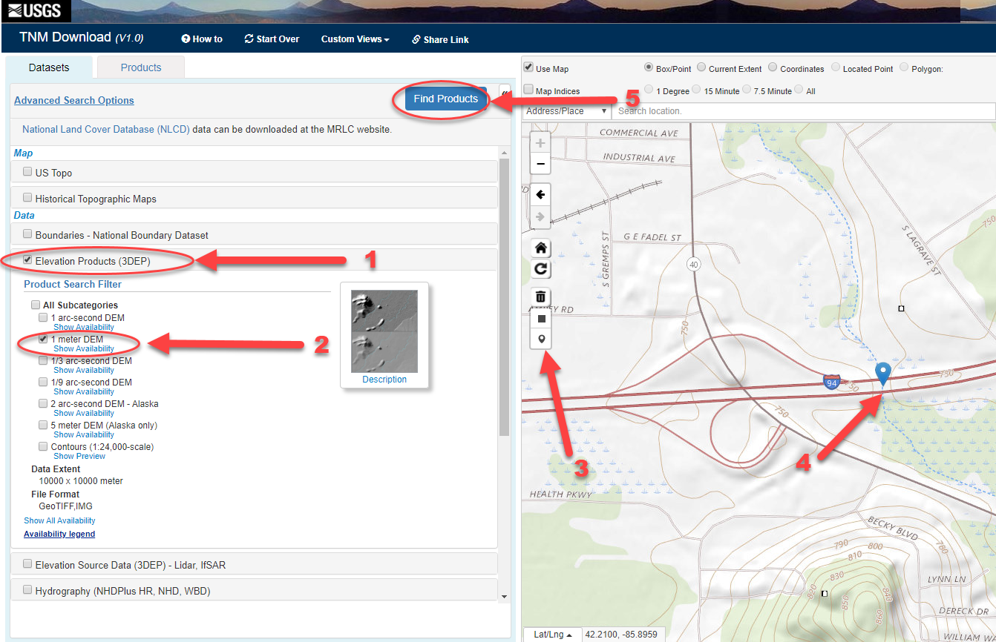

Then click the “Download” button on the most recent DEM
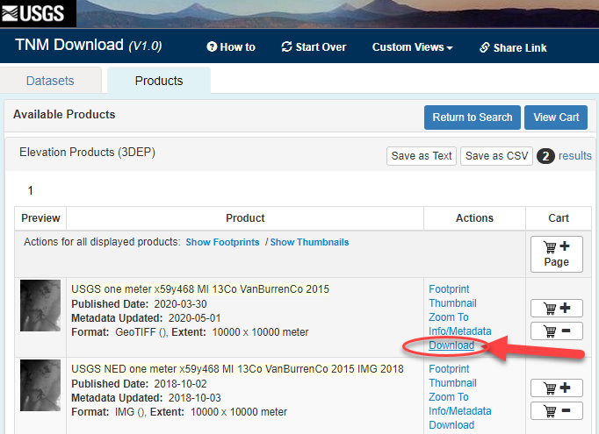

- *Next we need to bring the downloaded raster DEM into ArcMap or ArcPro in order to clip the DEM to a smaller extent. Making the DEM smaller will take up less memory and make the model more efficient. It is not necessary to always clip the DEM, but it is best practice to decrease processing times and use less storage.
Add the DEM to ArcMap, the easiest way is to Drag and drop the downloaded file into ArcMap:
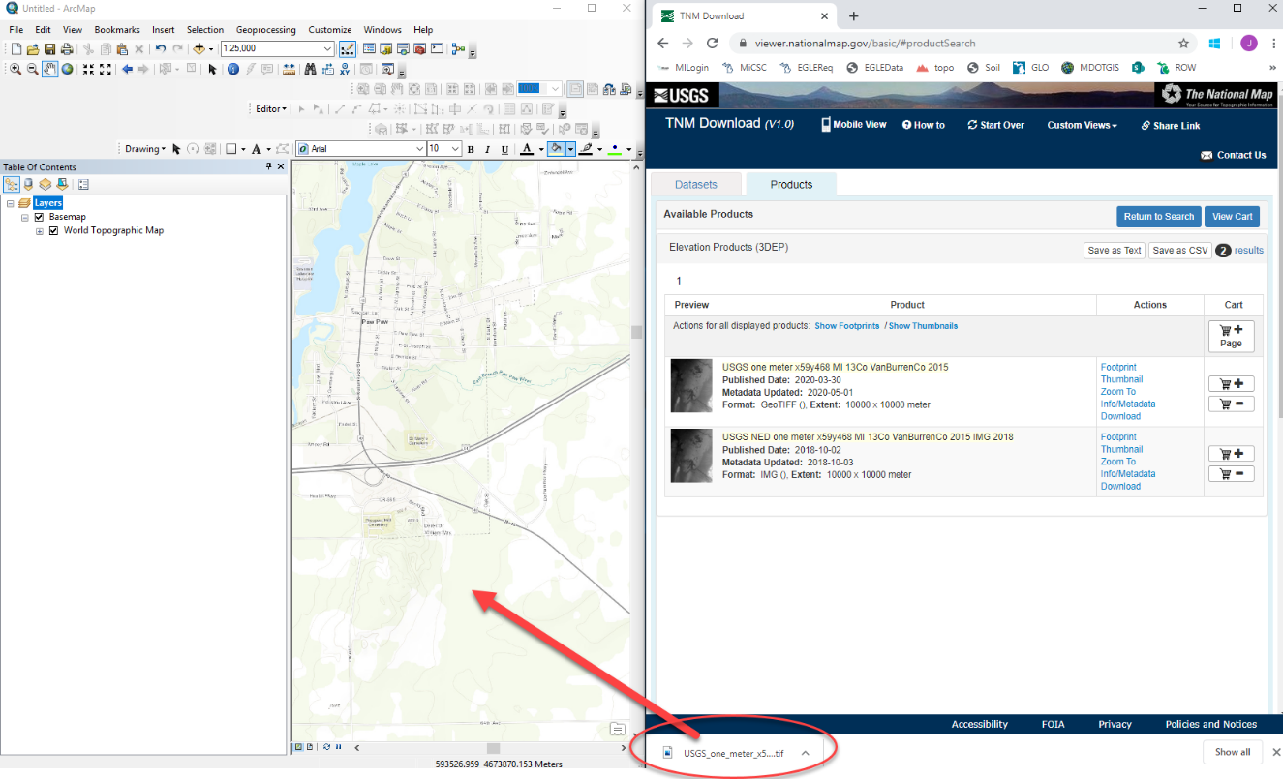
*If using contours to delineate watershed areas, verify that the limits of the DEM are beyond the watershed limits from a USGS topo map.
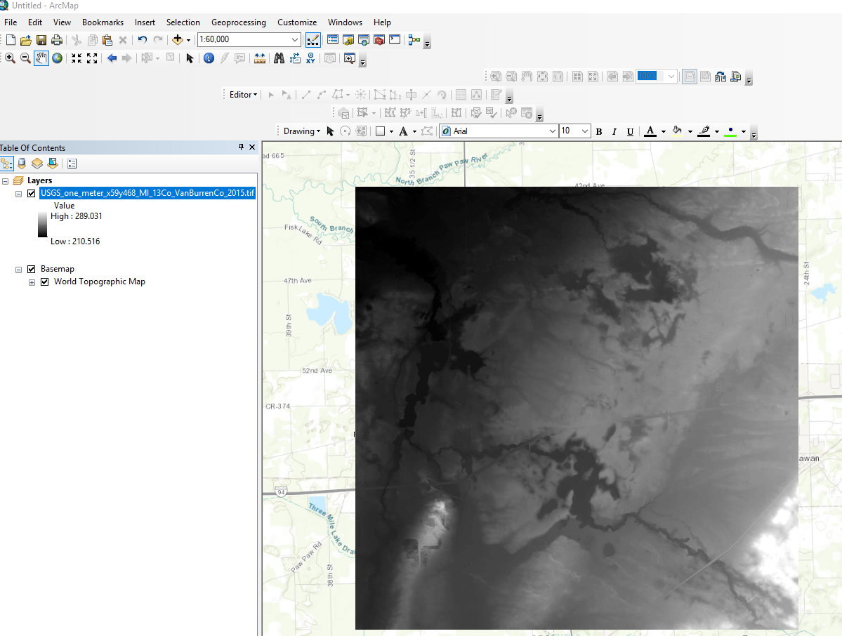
Next zoom into the area you need in order to delineat watersheds We are going to clip the DEM by the extents of your view window, so zoom in and make sure the area you need is covered. Always clip the DEM a little outside of the extents you need to be safe.

Turn off the DEM layer, and add a base map. Use this base map to zoom into the area you need. Next turn on the DEM layer. Right click it, and click export data, as shown:

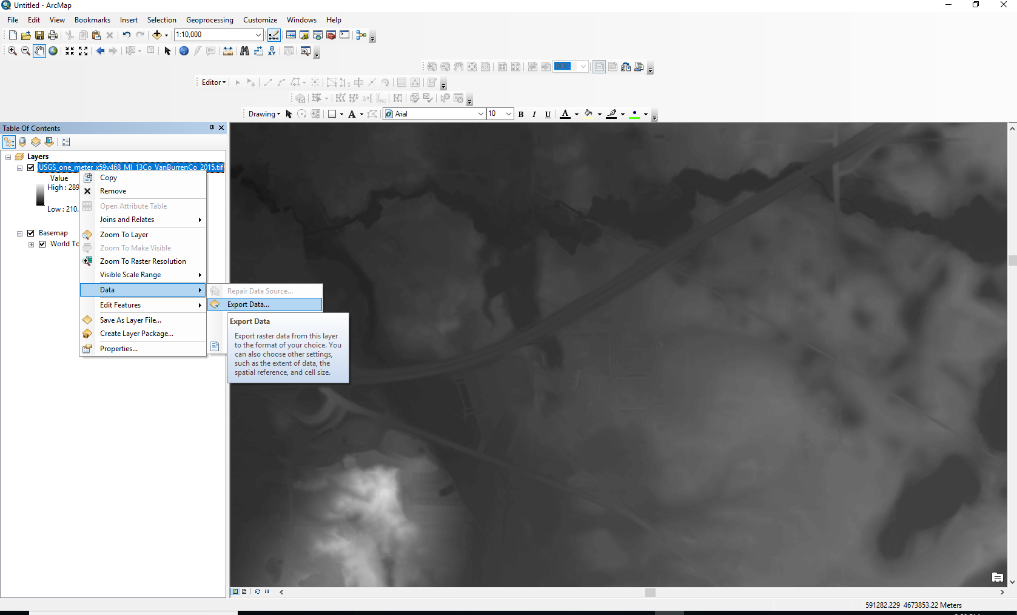

Make sure to click the button next to “Data Frame (Current)” under Extent, make sure you save it in the correct location, then save, as shown:
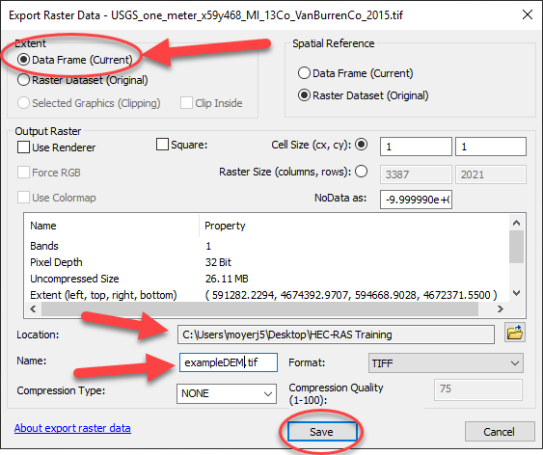

Verify the DEM was clipped correctly. It may be necessary to bring in and clip multiple DEM data sets, if your project falls near the boundary of the DEM tiles.
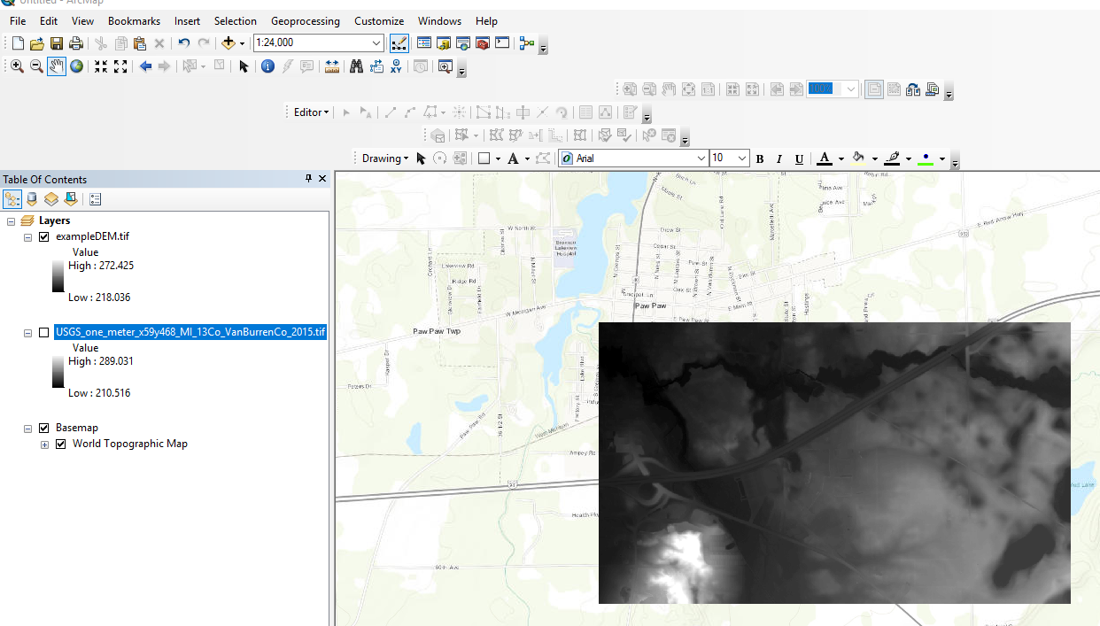

- Next we need to go back to ORD and bring the Terrain in. Verify that you are in “OpenRoads Modeling” in the upper left corner of the main screen.

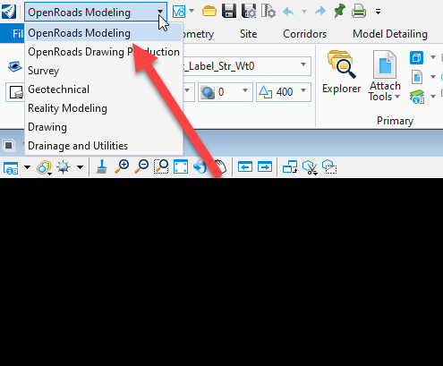
- Verify that you are operating with the correct coordinate system. In the tool search ribbon (typically in the upper right corner), type “coordinate” and select “Geographic Coordinate System.”
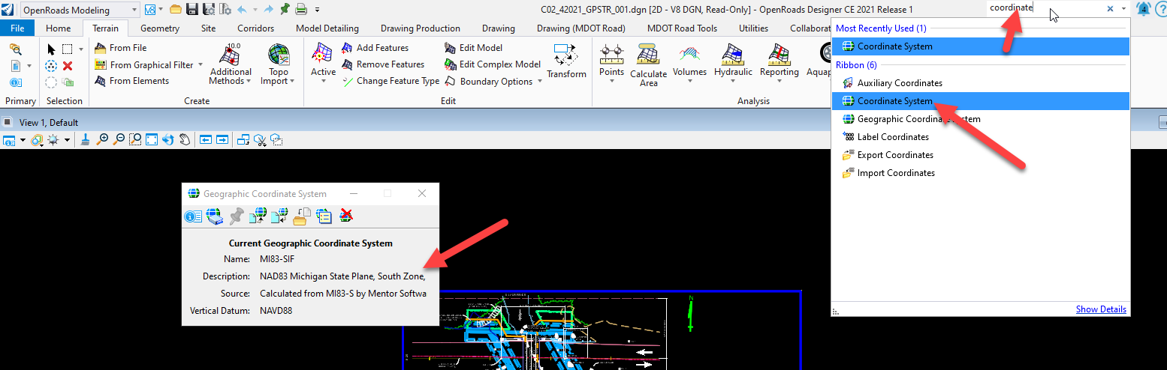
- Once the coordinate system is verified, we will create a new terrain from the DEM .tif file from Steps 1 and 2. In the upper right search ribbon, type “terrain” and select “Create Terrain Model From File.”

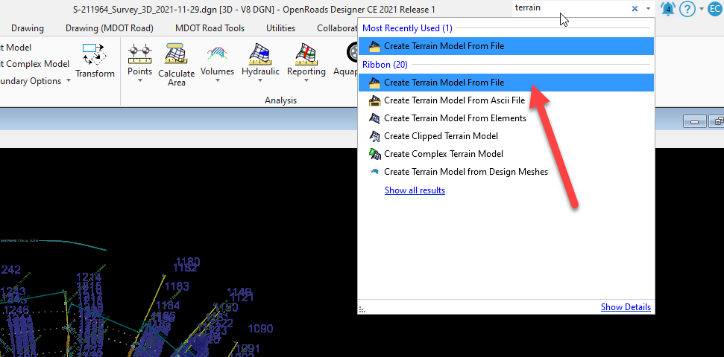

Change the file type to “TIF file (.tif)” and select the appropriate DEM tif. Select “Done.”

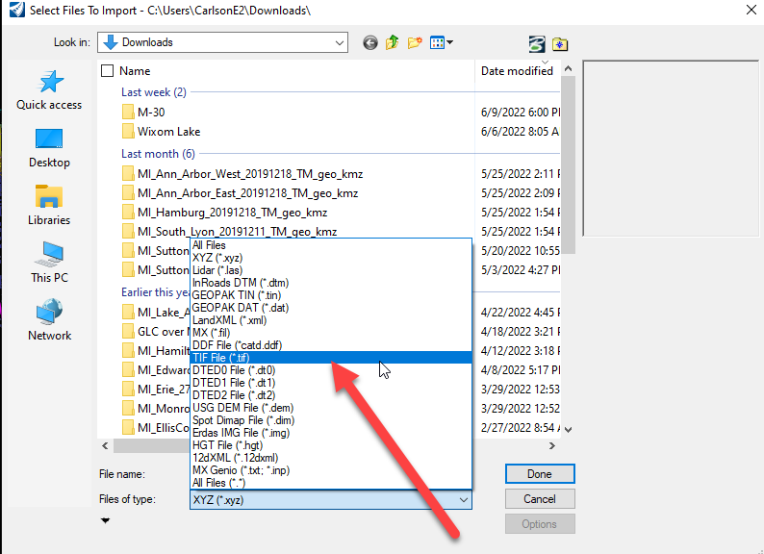

Select “Import.”

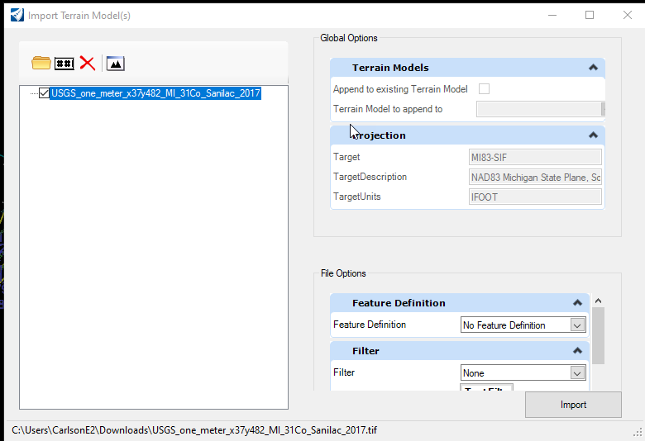

- Select one of the triangles in the terrain and hover over the new terrain file with your mouse cursor until the property menu appears. Select the first icon on the left (Properties).

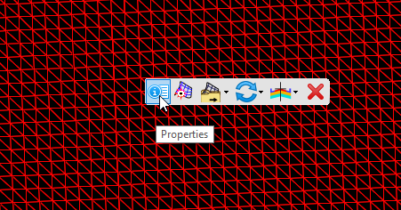

- Turn the Major and Minor Contours on and the Triangles off to view the contours. Hover your mouse over each contour to verify elevations.

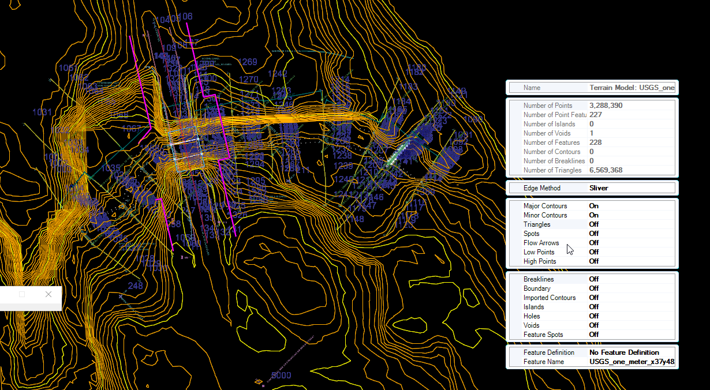

- Add background images through View Attributes, located in the upper left corner of the View. Select the appropriate image in the Background Map Type (recommend “Hybrid”).
