**SignCAD Tips and Tricks**

**Problem:** SignCAD file for Williams Rd dimensions on the edges don’t balance.  The top sign is 48.1 inches not 48”.

**Solution:** For the Williams Rd file, the spacing from the text to panel edge is displaying like this because the “Round Lengths to nearest eighth inch” box is checked under Preferences\Drawing\Style and the Decimal places = 1.

**Broken File: Fixed File:**

 

Note: Drag & drop the above files to your Desktop for testing.

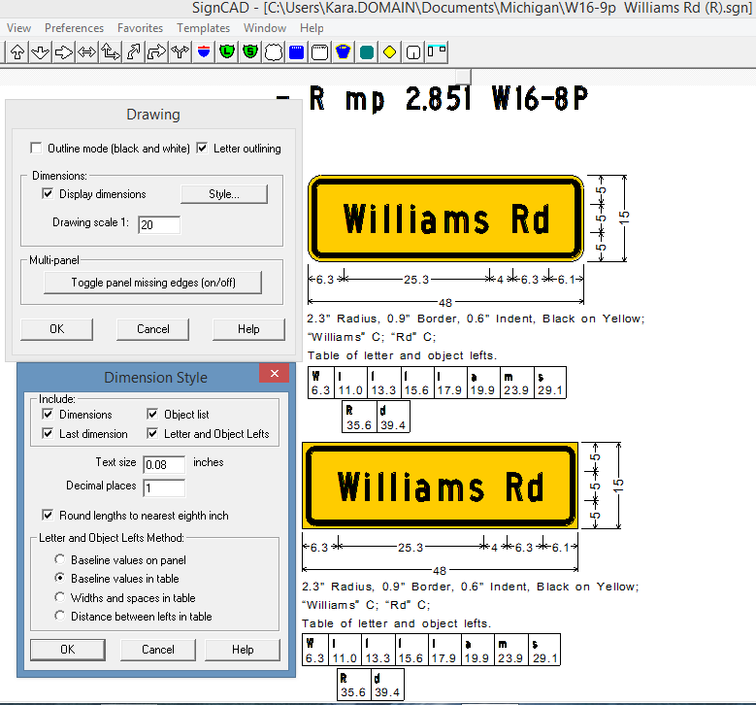

If you uncheck the “Round Lengths to nearest eighth inch” box and press OK to both dialog boxes, then the dimensions will display equal as shown below.

***Continued on next page …….***

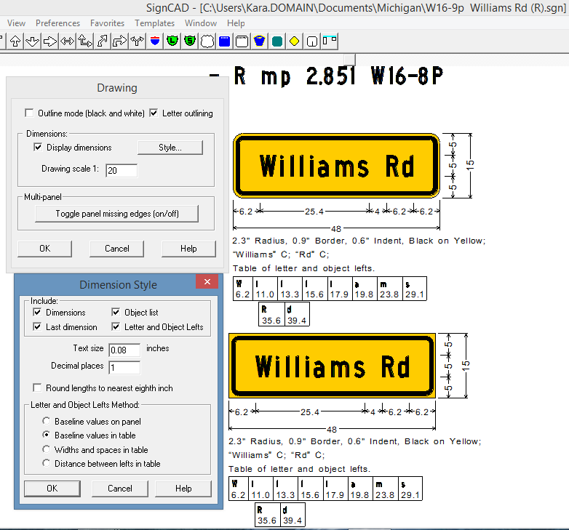

If you want to keep the “Round Lengths to nearest eighth inch” box checked, then your other option is to set the Decimal places = 2 as shown below.

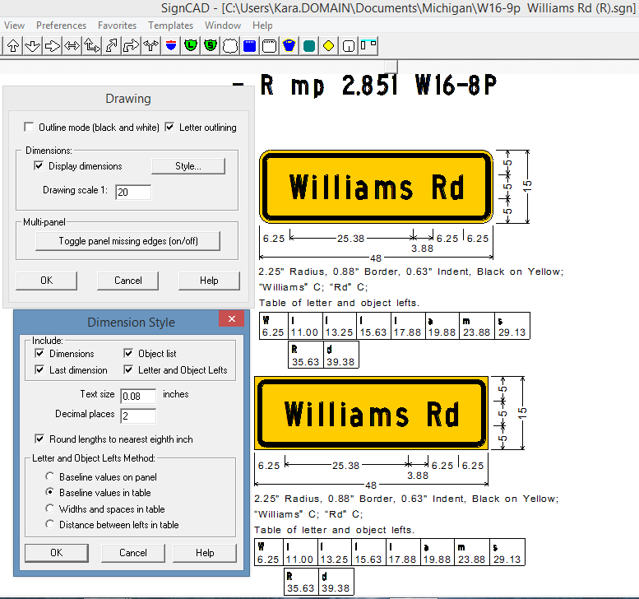

**Problem:** The fill color on the diamonds works, but the fill color on the rectangular sign changes the border instead.

**Solution:** When using the Rectangular panel, specify the desired panel color under the General tab in the Rectangular Panel dialog box.

**Broken File:**



Note: Drag & drop the above files to your Desktop for testing.

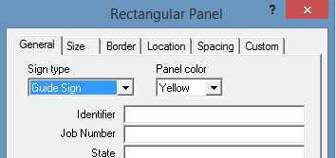

***Continued on next page …….***

**Problem:** County route markers, Federal code M1-6, our code is M1-5, should be blue and gold including all legends (route number and county name).  Also, numbers are not placed correctly.

**Solution:** For the county route markers, the standard in this file is set to U.S. instead of Michigan (Preferences\Standard) and that is why the county route markers are not displaying as expected.

**Broken File: Fixed File:**

 

Note: Drag & drop the above files to your Desktop for testing.

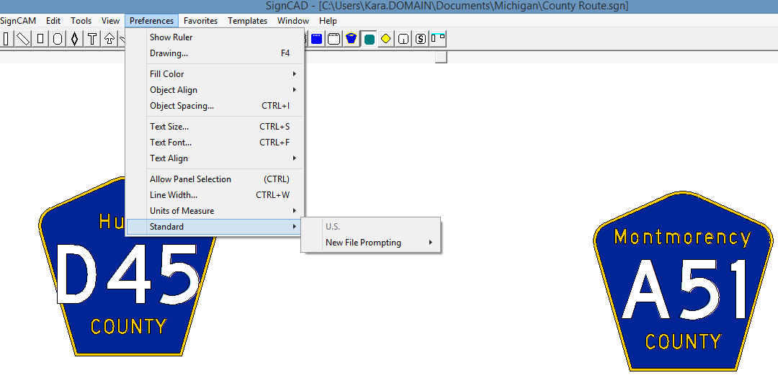

Pick File\New and select the Michigan standard.  The Pentagonal County shields in the Michigan standard display with blue and gold.  If the route number doesn’t fit within the shield, you can convert the shield to a graphic (Edit\Convert to graphic) and then modify the spacing in the Graphic View and Edit to get the route number to fit (see shields in bottom row).  You can also add the M1-5 in the Graphic Description box if you would like that to display in the object list.

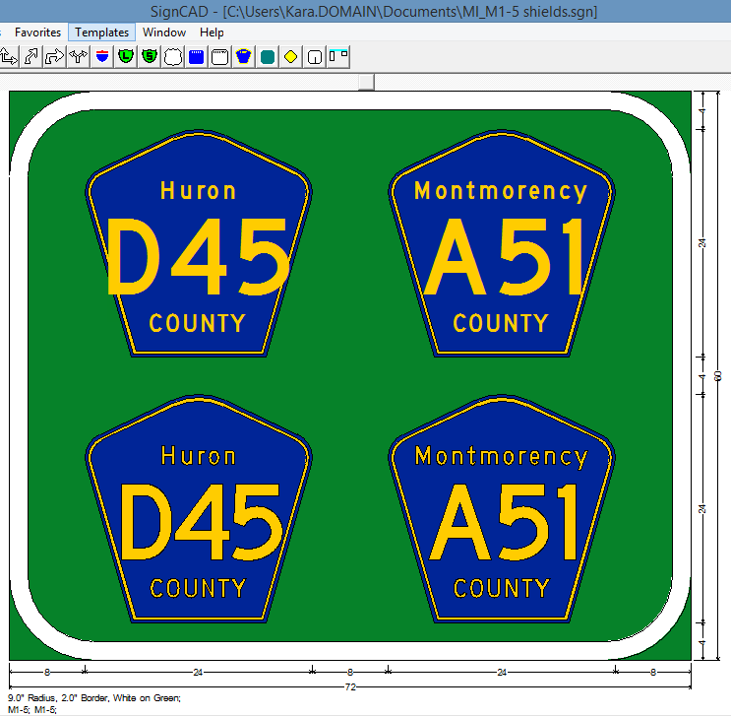

Attached are revised files for Williams Rd and the Pentagonal County shields.

**Problem:** Unable to import a file from SignCAD to Power GEOPAK when it contains graphics. Note: This is a Bentley problem that is specific to MicroStation SS4 & Power GEOPAK SS4 and does not occur in the CONNECT versions.

**Solution:** I’ve had this happen to me before in SS4 with certain graphics or objects in the sign I’m trying to place.  You can try placing some signs with just text into MicroStation to see if you still get the error.  If the signs with just text come into MicroStation okay, then a graphic or object in the sign is causing the problem in MicroStation. Here are steps to fix your graphic or object in SignCAD:

**Broken File: Fixed File:**

 

Note: Drag & drop the above files to your Desktop for testing.

1. Select the Crash graphic in the sign and pick File\Export Selected\Plot HPGL-2 File.

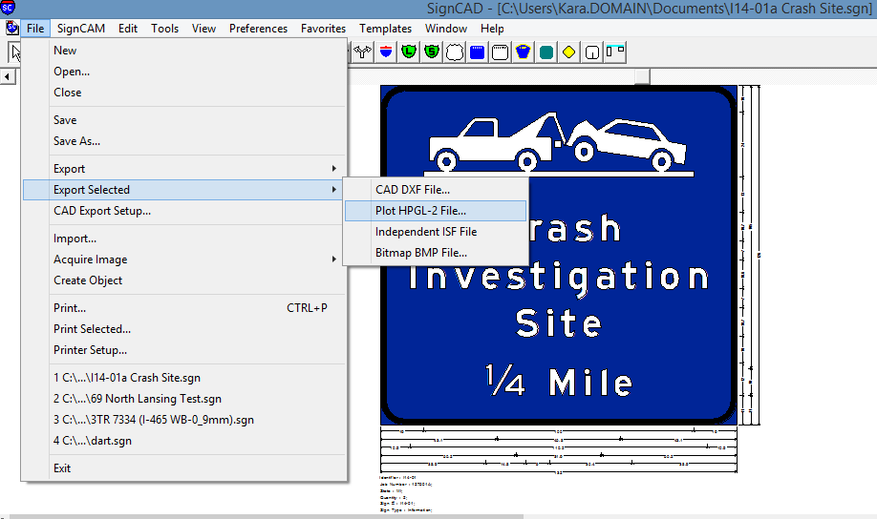

1. Save the graphic as a .plt file

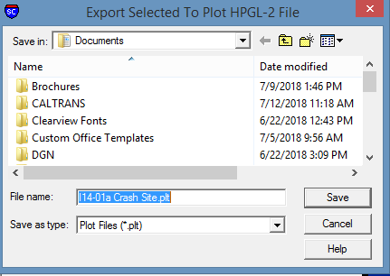

1. Press OK to the Export dialog box (settings don’t matter).

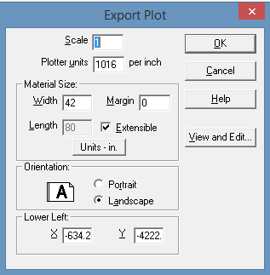

1. Import the .plt file back into SignCAD (File\Import).  Select the file and press Open.

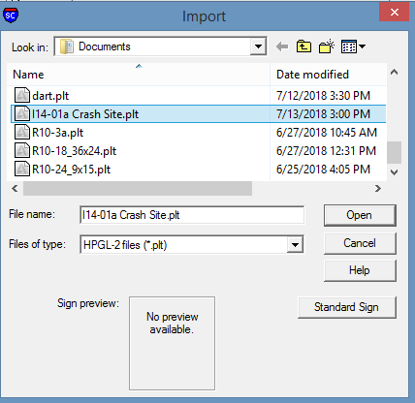

1. Select and drag the imported graphic close to the sign work in your file.

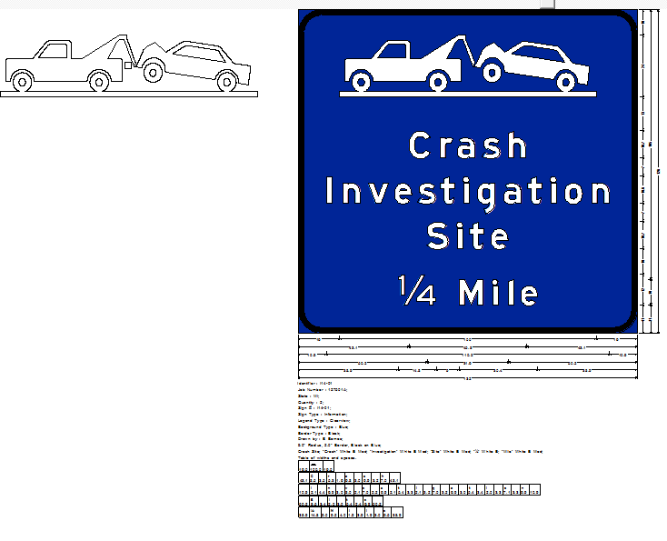

1. Right click on the new graphic outside of the panel and pick Edit Data from the floating menu.  In the Graphic dialog box, press the View and Edit button.

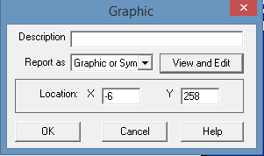

1. In the Graphic View and Edit, add back the fill color on the graphic.  Do not weld.

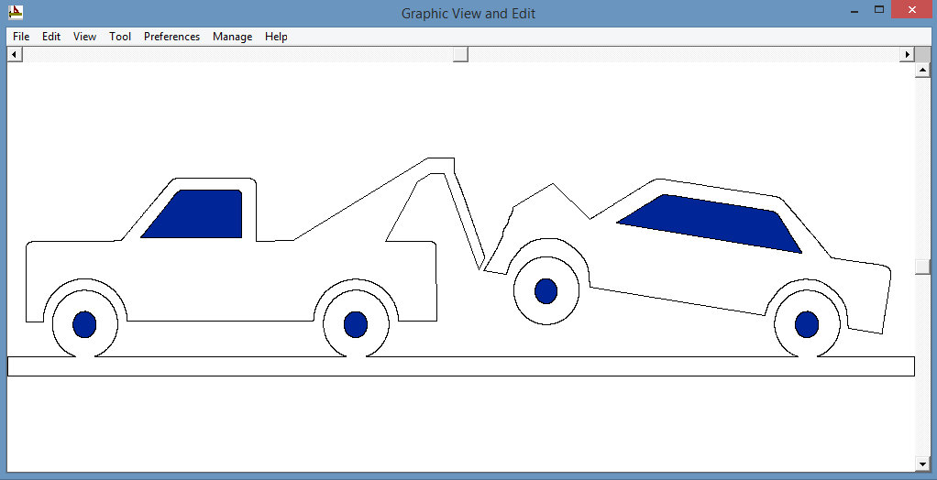

1. Save your changes to the graphic (File\Close, Yes to save changes) and press OK to the Graphic dialog box.

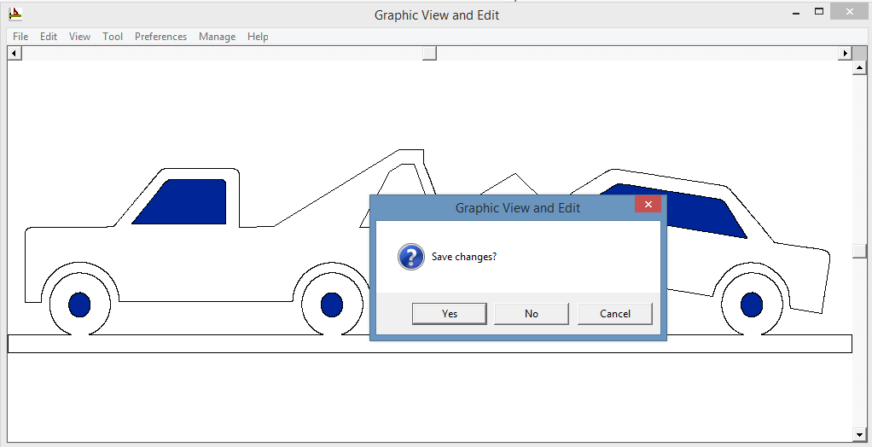

1. Look at the current Object Spacing on the existing graphic.

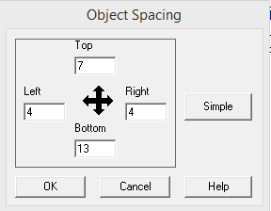

1. Delete the graphic currently in the sign and replace it with the new graphic.  Adjust object spacing using values from Step 9.

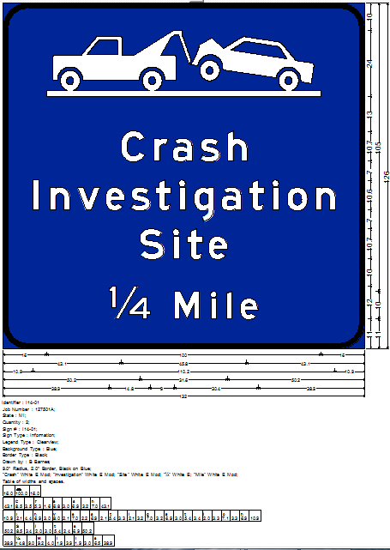

1. Bring sign over into MicroStation.

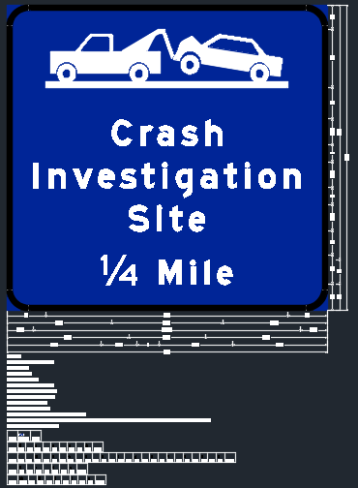

Attached is the revised SignCAD file for you to try.