Creating a Digital Seal for use in the DocuSign Signature Appliance Client

General Information

This document provides guidance for creating a digital version of a Professional Engineer or Professional Surveyors seal to be used with a DocuSign SA digital signature.

Procedure

- On Page 4 of this document, customizable seals for both Engineers (top image) and Surveyors (bottom image) are provided. Customize the seal(s) by clicking on the text block to edit the text.
Click in text block to edit text
- Once the seal has been customized, the seal must be converted to a JPEG picture in order to be used as a signature. For the best quality seal, use the following procedure.
  - Zoom in on the seal so that it fills the entire view
  - Take a Print Screen of the window that includes the seal and open in either Snagit Editor or Windows Paint.

  - Crop the picture to only include the seal.

  - Save the picture as a JPEG on your computer.
- Open the CoSign Control Panel (All Programs>DocuSign>Signature Appliance Control Panel) and select the Graphical Signatures button.

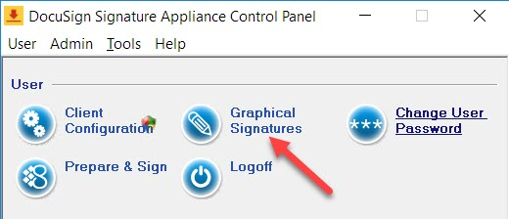

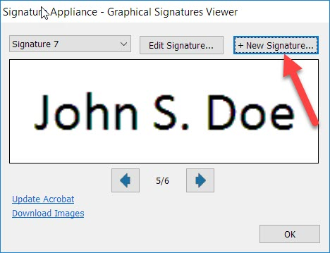
- Select + New Signature…

- Name the signature. Select Upload and navigate to where the image is saved, select Open. Save when complete.
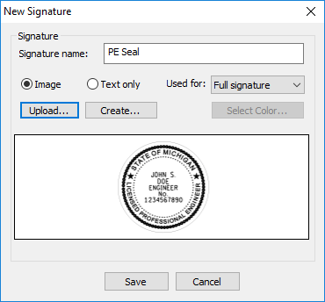

Technical Support

Please email any questions, issues or problems associated with this document to:

MDOT-eSign@michigan.gov

JOHN S.
DOE
ENGINEER
No.
1234567890
JOHN S.
DOE
PROFESSIONAL
SURVEYOR
No.
1234567890

